**Practical-9**

Project Management Tool (Taiga)

# What Is Taiga?

* Taiga is a project management platform for agile developers& designers and project managers who want a beautiful tool that makes work truly enjoyable.

# Powerful

* Customize everything. Easily. You are in full control.

# Simple & Intuitive

* Figuring out the tool is ridiculously easy.

# Highly Designed

* Simple & Gorgeous! Beautiful to look at all day long.

# Customizable

* Give each project its own personality.

# What Is Scrum?

* Scrum is an iterative and incremental agile software development methodology for managing product development.
* The product backlog is what will ultimately be delivered,ordered into the sequence in which it should be delivered.Product Backlogs are broken into manageable, executable chunks named sprints. Every certain amount of time the team initiates a new sprint and commits to deliver a certain number of user stories from the backlog, in accordance with their skills, abilities and resources. The project advances as the backlog becomes depleted.

# How to Register For Taiga?

* [**https://www.taiga.io/**](https://www.taiga.io/) Goto This Site And Click On Start Free Trail.

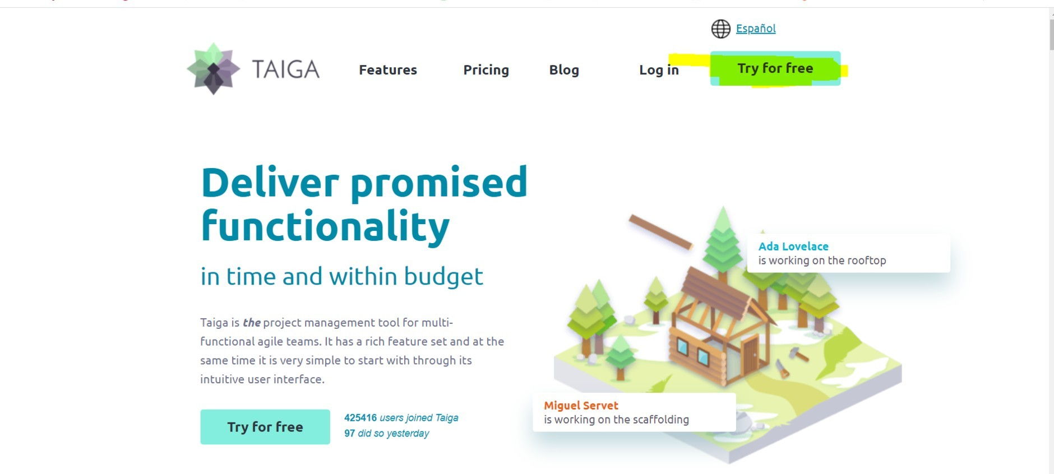

* When You Click On Try For Free,One From Will Display Fill It.

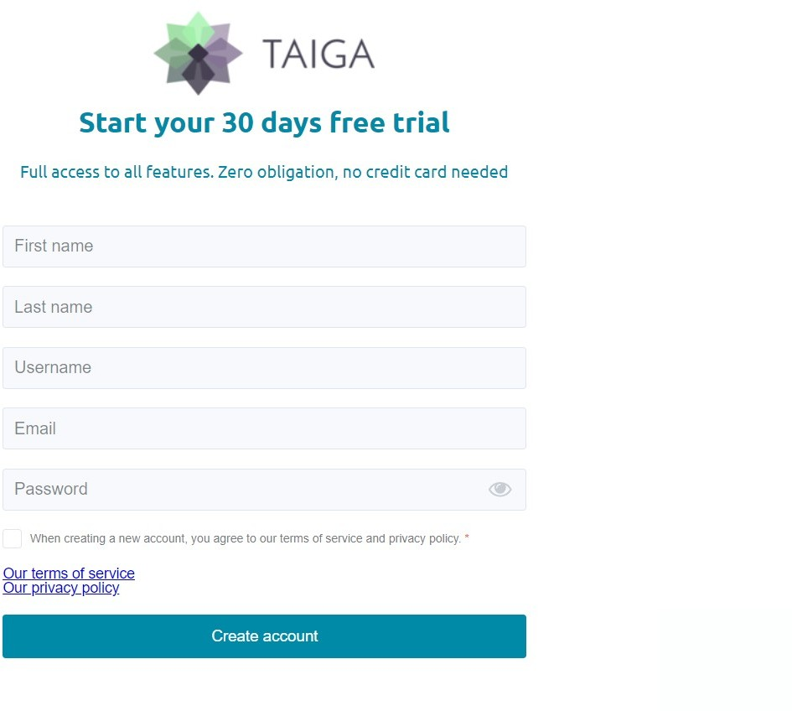

Fill Details And Create Accout To Use Taiga.

After Registration You Will Redirected To Loging Page For Login:-

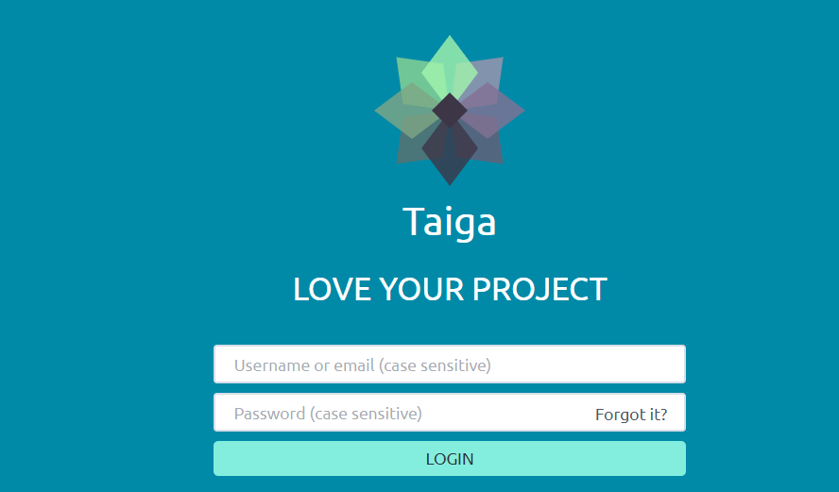

* 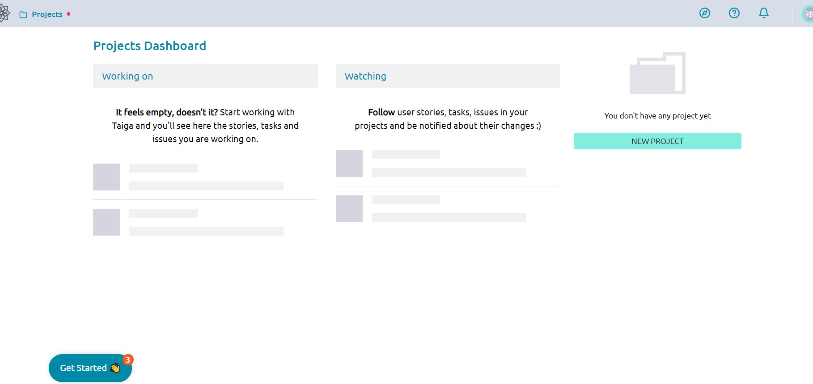After Login You Will Goto Home Page Of Taiga.
* To Create Project On Dashboard Click On Create Project.

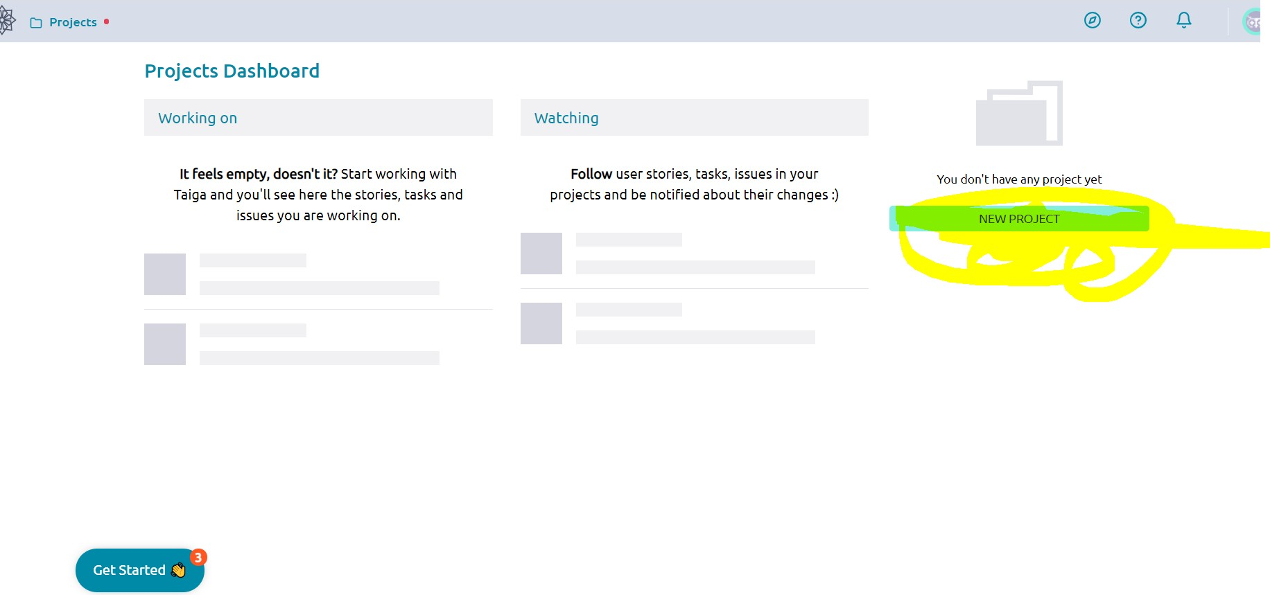

* Select Project Approach,We will Select Scrum.

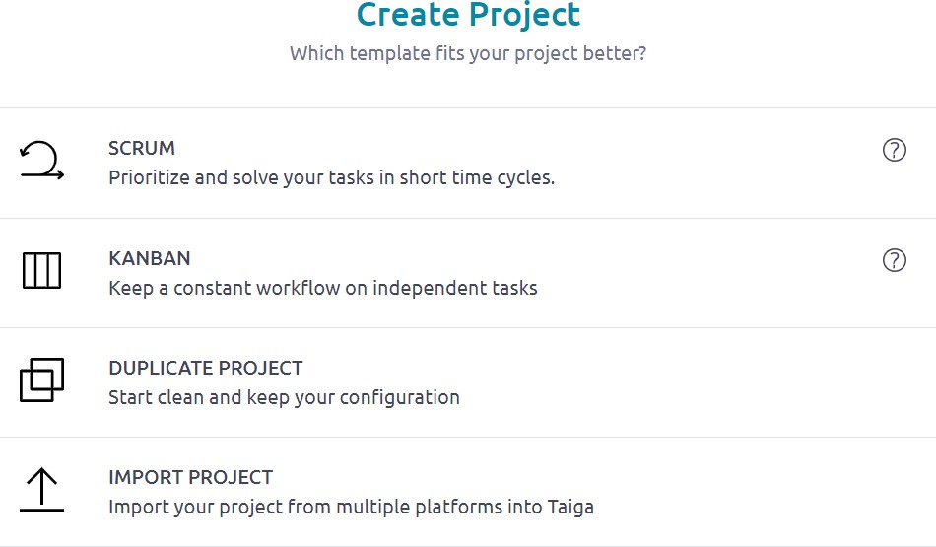

* After That Give Project Details And Click On Create Project To Create Project

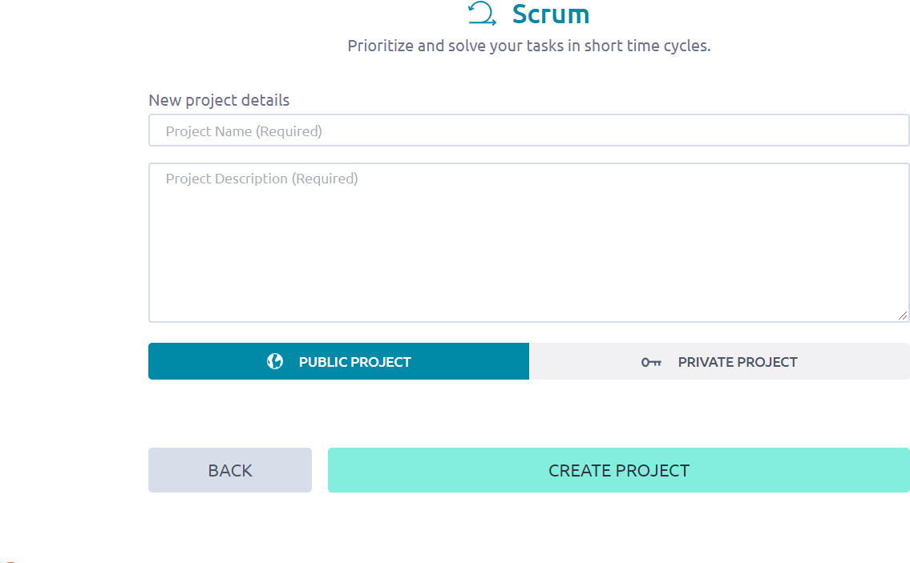

* You Will Move To Home Page Of Your Project.
* Where You Can Create Backlogs,Sprints,User Stories,etc

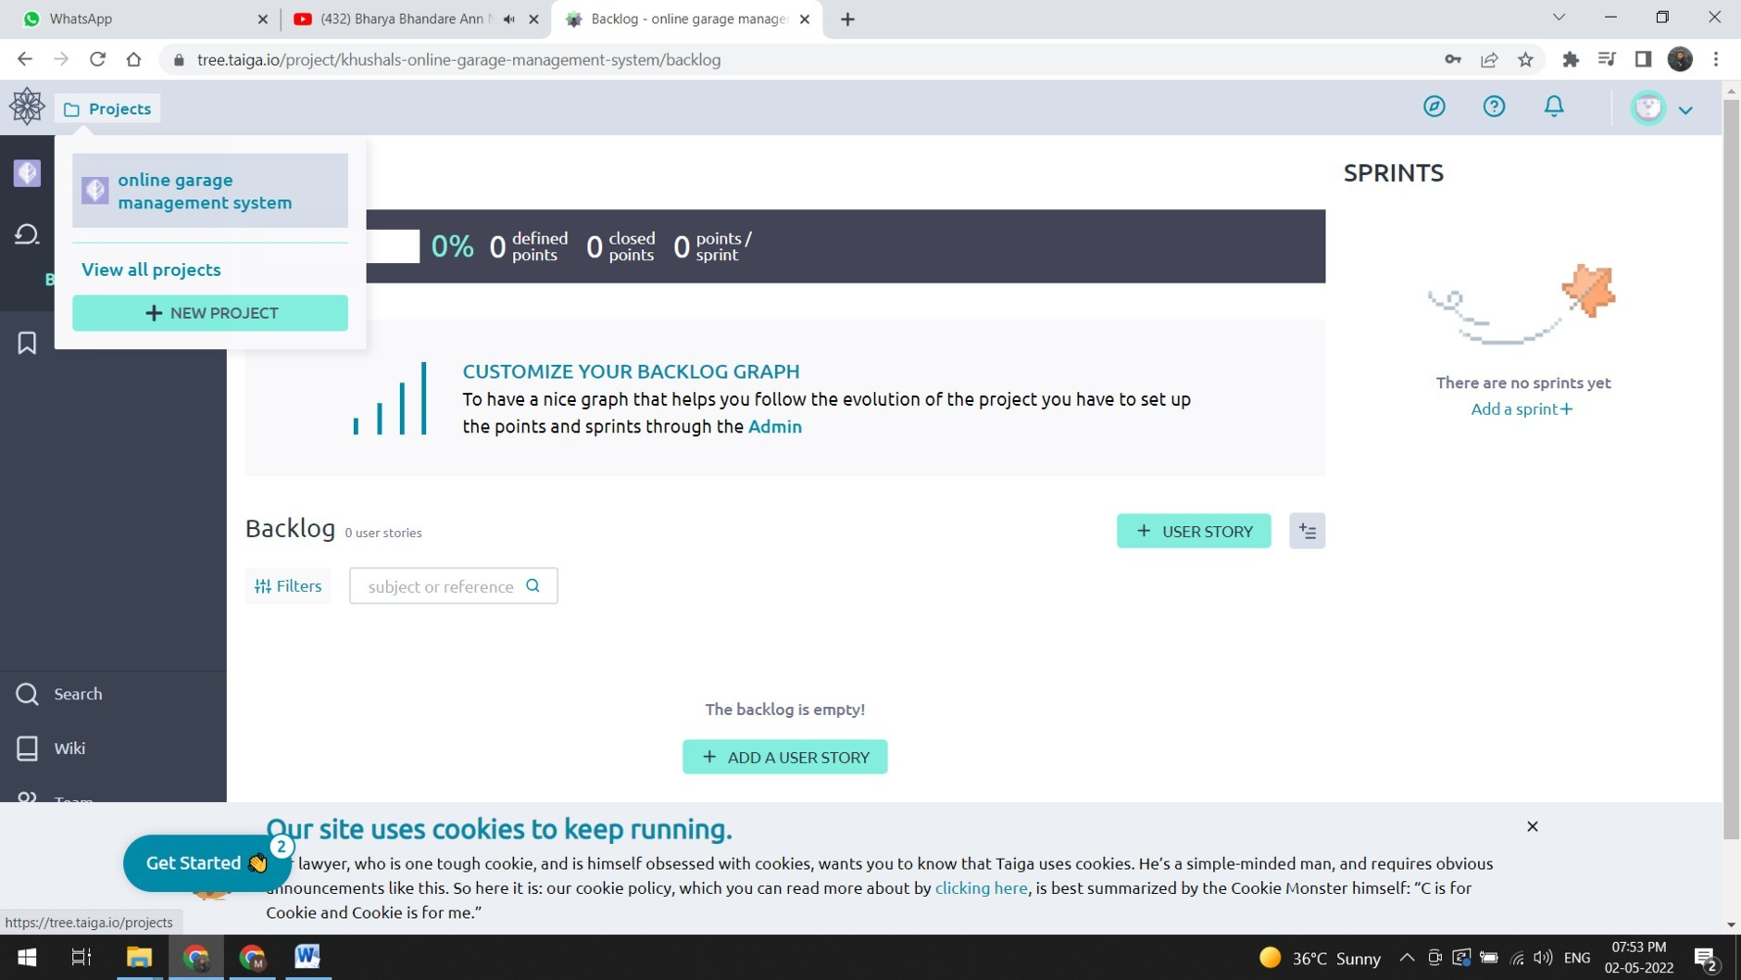

* To Create User Story Click ON Add User Story:-

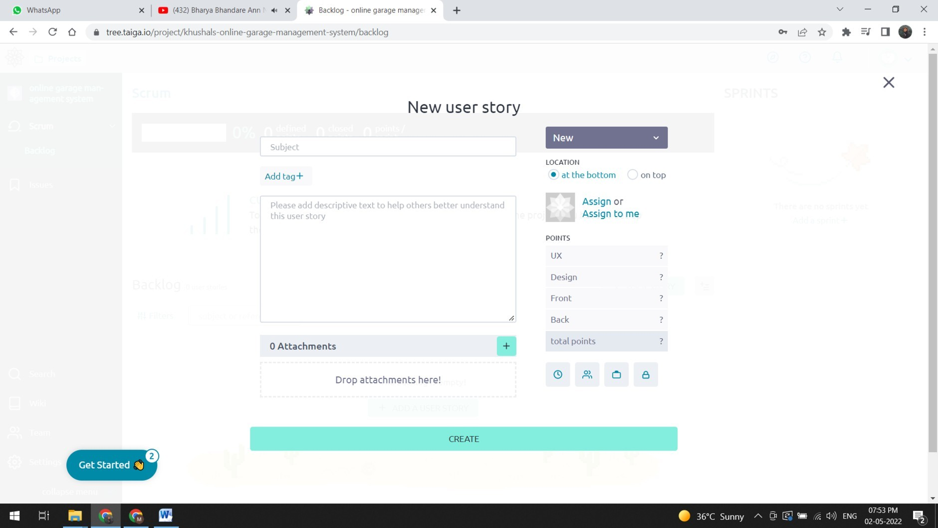Give Details About Story And Click On Create.

* To Create Sprint Click On Add Sprint And Fill Sprint Details.

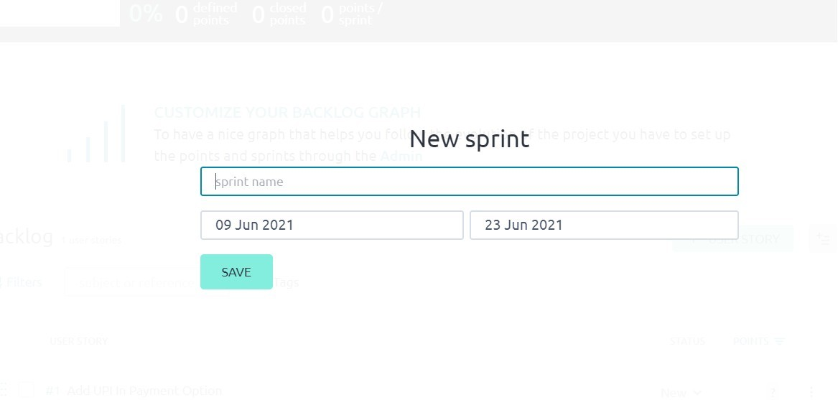

* To Create Issue Goto Issue In Menu Of Of Project.

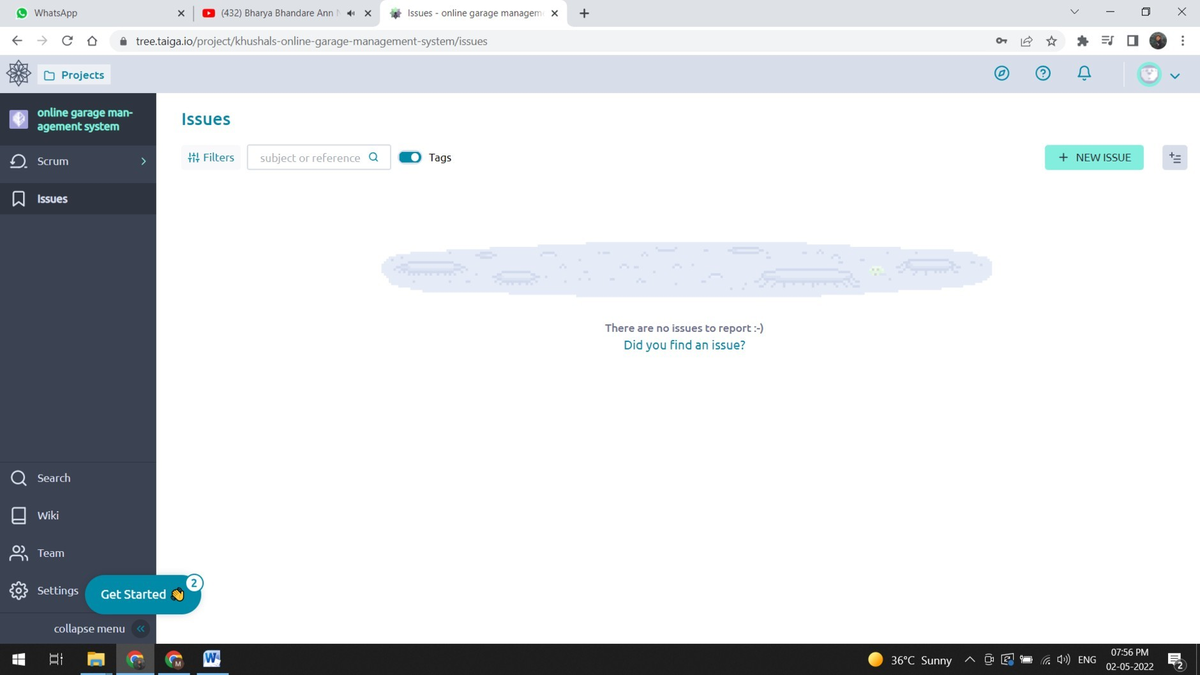And Click On New Issue To Generate Issue.

How can you change permissions in Taiga? Write steps to create new points value in Taiga.

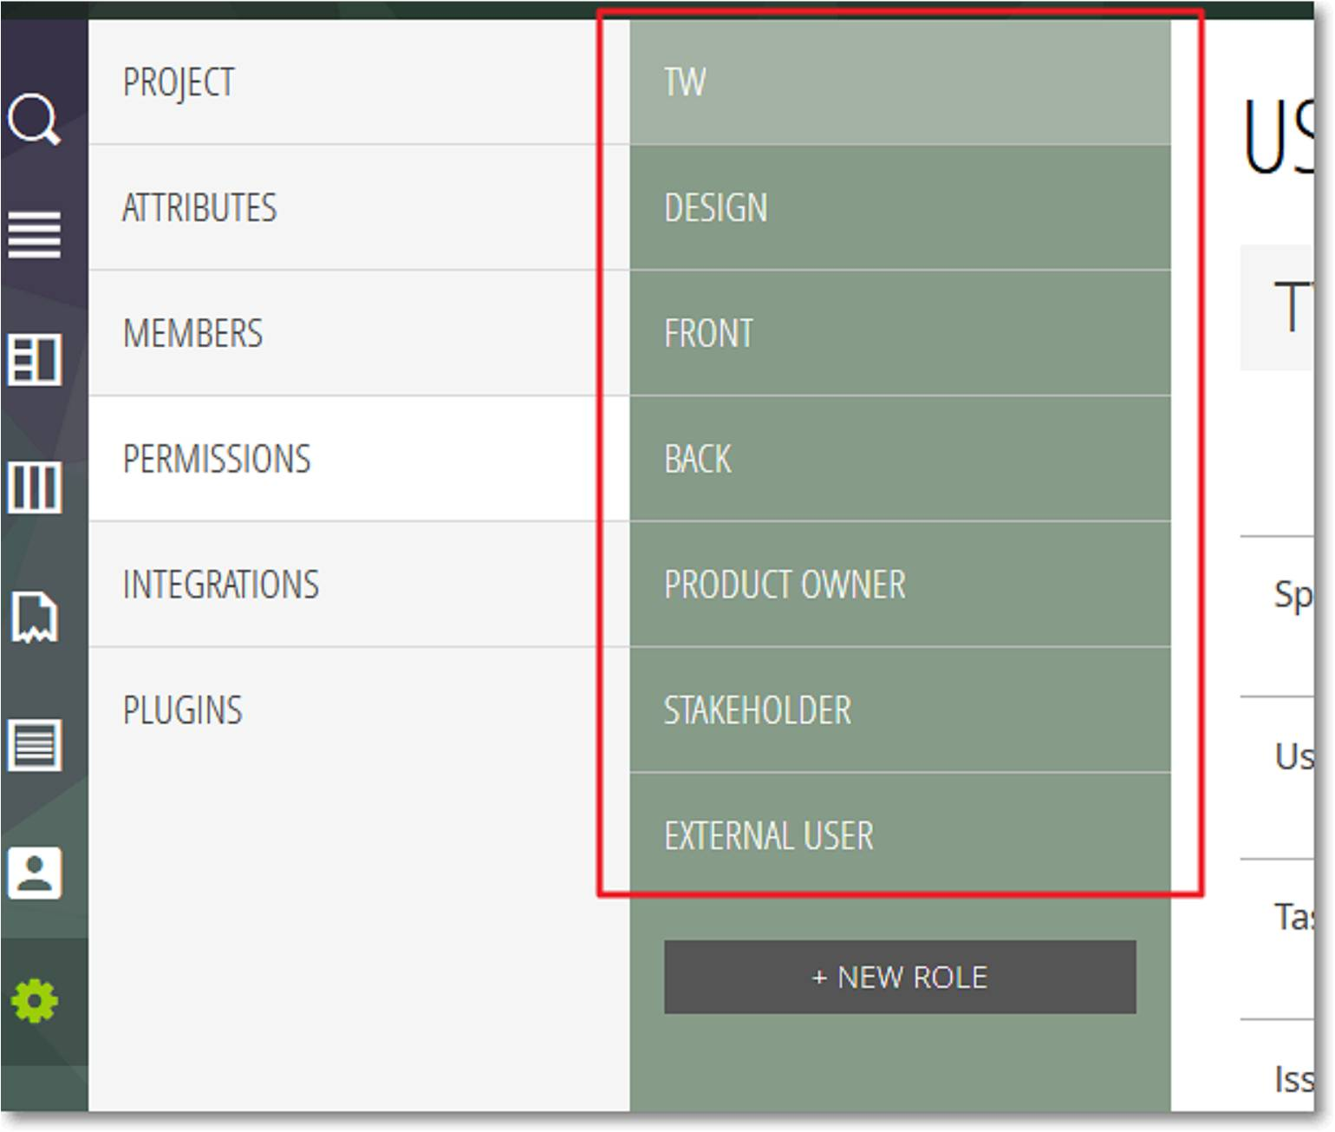

* To manage the access rights that each role grants, click the name of a role – this action displays the manage rights form on the right side of the list that shows the existing roles.

For each role, you can manage access rights for the following elements of the current project:

* + Sprints – the actions that you can enable or disable for Sprints are: view, add, modify, delete
  + User Stories – the actions that you can enable or disable for User Stories are: view, add, modify, delete
  + Tasks – the actions that you can enable or disable for Tasks are: view, add, modify, delete
  + Issues – the actions that you can enable or disable for Issues are: view, add, modify, delete
  + Wiki – the actions that you can enable or disable for Wiki pages are: view, add, modify, delete and for Wiki links: view, add, delete

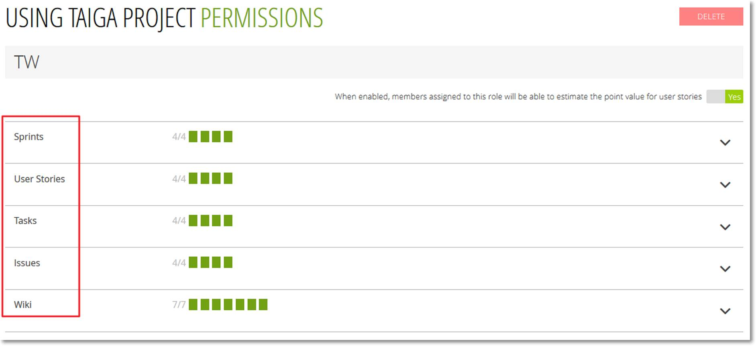

Fill Details About Your Issue And Click On Create To Create Issue.

